SWAPPING OF NUMBERS

EXP NO: 14

BEFORE SWAPPING

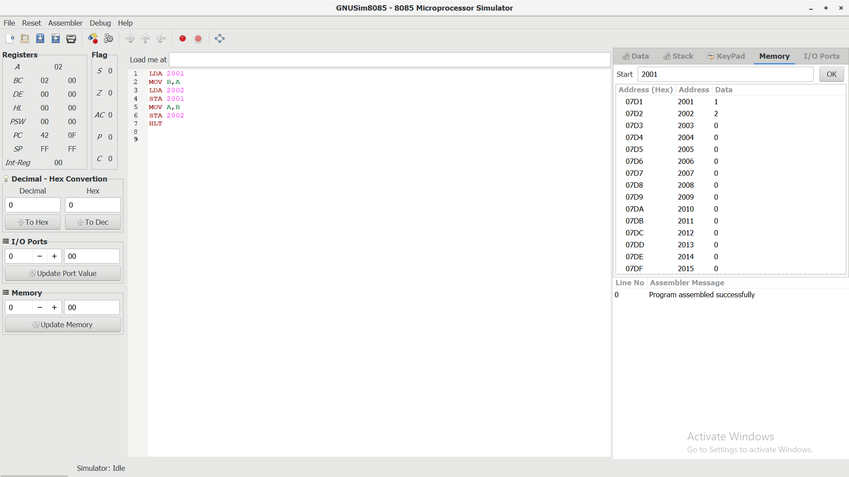

AFTER SWAPPING

